Bundaberg District Cross Country
Date: Tuesday 2nd May 2023
Venue: GIN GIN STATE HIGH SCHOOL
Time: 3:15pm course briefing, 3:30pm start, 4:30pm finish

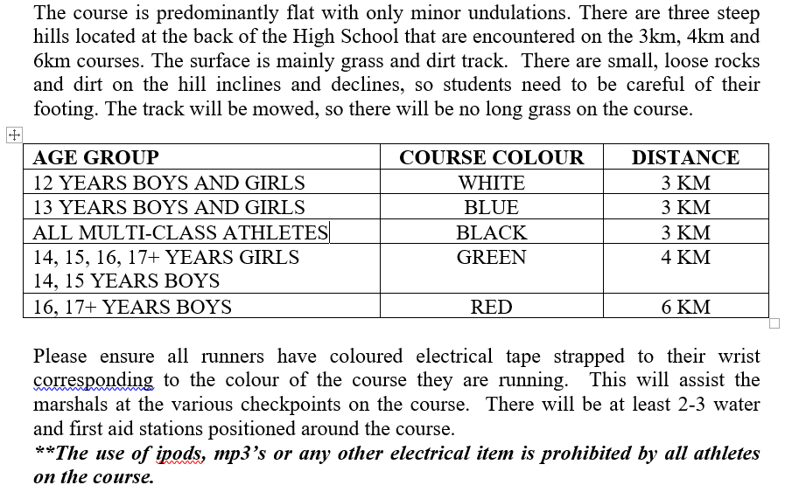
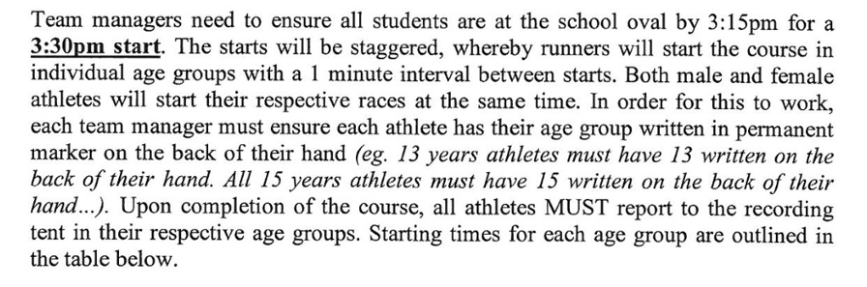
START TIME | AGE GROUP | YEAR OF BIRTH | COURSE RUN
3:30 | 17+ BOYS | 2004/2005/2006 | 6KM
 | 16 BOYS | 2007 | 6KM
3:31 | 17+ GIRLS | 2004/2005/2006 | 4KM
 | 16 GIRLS | 2007 | 4KM
3:32 | 15 BOYS AND GIRLS | 2008 | 4KM
3:33 | 14 BOYS AND GIRLS | 2009 | 4KM
3:34 | 13 BOYS AND GIRLS | 2010 | 3KM
3:35 | 12 BOYS AND GIRLS | 2011 | 3KM
3:36 | PARA ATHLETES | VARIOUS | 3KM

Please ensure that all students are nominated by completing the attached nomination form by emailing to me cmtay1@eq.edu.au ASAP.

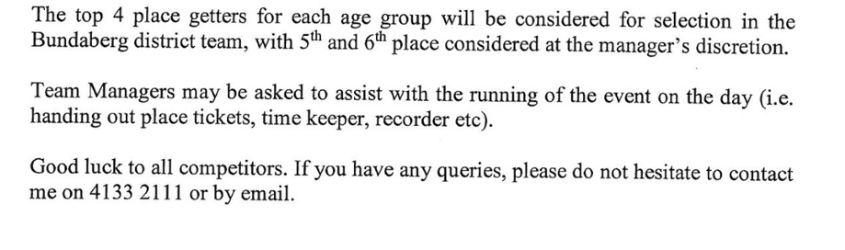

Thanks,
Caitlin Taylor

Sports Co-ordinator
Gin Gin SHS

JOBS LISTS
After speaking with some staff members, we are making a few changes this year to allow for first place winners to have their times recorded

TIMERS | Rowan Sutton (Help to identify first place students of each age group - Radio)  12 YEARS - Smith  13 YEARS - Sutton  14 YEARS - Kitt  15 YEARS - Danziger  16 YEARS - Shultze  17+ YEARS - Goodman
CHIEF RECORDER: | Matt Ward – Records boys  Michele Ridge – Records girls
RECORDER HELPERS: | Leisa Ross  Laura Wenham  Sally Christiensen  Liz Walker
CONVENOR/STARTER: | Taylor - Radio
TIMERS / TICKETS | Ross / Matthew /M. Finlay / Stehbens
FIRST AID: | Taylor
OFFICIAL PHOTOGRAPHER: | Gregson
STUDENT SUPERVISION: | Prisk
STUDENT WATER HELPERS: | - Sutton to organise year 12 students
MULTICLASS AIDES: | Newton, Frear, Hudson
BIKE | Napier

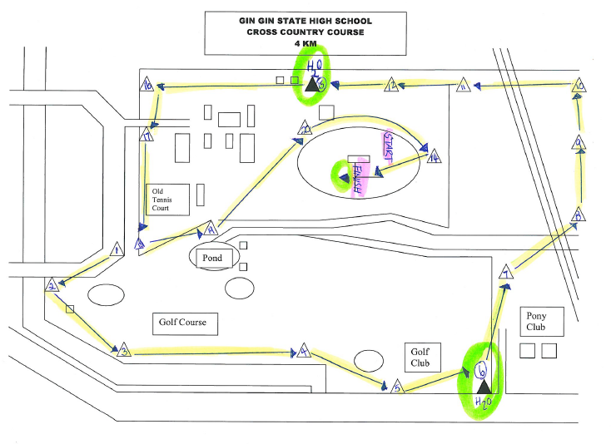
Course Marshall Position
(Refer to 4KM Map)
- Olney
- Webster
- Gonda
- Quinn
- Herbert
- Terlier (Water Station)
- Reck
- Bechly
- A. Wilson
- Kreis
- Zunker
- Cappello (Direct on 3 or 4km course - Radio)
- C. Wilson*
- Jamie Acworth
- Wesche (Water Station)
- Roberts
- Scott
- Dinham – (final walker after 4kms students - Radio)
- Jane Acworth
- Hume

*For the location of #13 see below
