**Bundaberg District Cross Country**

**Date:** Wednesday 8th of May 2019

**Venue:** GIN GIN STATE HIGH SCHOOL

**Time:** 3:15pm course briefing, 3:30pm start, 4:45pm finish

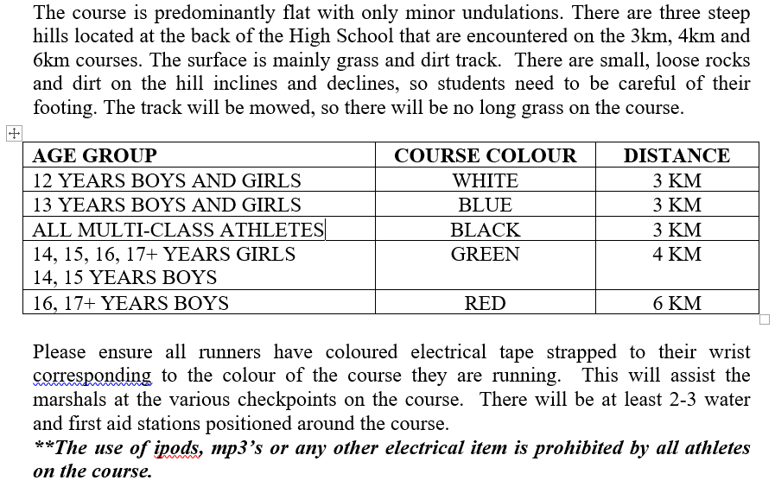

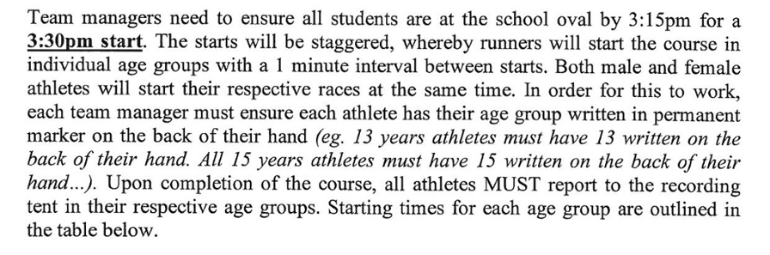

|  |  |  |  |
| --- | --- | --- | --- |
| **START TIME** | **AGE GROUP** | **YEAR OF BIRTH** | **COURSE RUN** |
| **3:30** | 17+ BOYS | 2001/2002 | 6KM |
| 16 BOYS | 2003 | 6KM |
| **3:31** | 17+ GIRLS | 2001/2002 | 4KM |
| 16 GIRLS | 2003 | 4KM |
| **3:32** | 15 BOYS AND GIRLS | 2004 | 4KM |
| **3:33** | 14 BOYS AND GIRLS | 2005 | 4KM |
| **3:34** | 13 BOYS AND GIRLS | 2006 | 3KM |
| **3:35** | 12 BOYS AND GIRLS | 2007 | 3KM |
| **3:36** | MULTI-CLASS | VARIOUS | 3KM |

Please ensure that all students are nominated by completing the attached nomination form by emailing to me [khayd19@eq.edu.au](mailto:khayd19@eq.edu.au) by the 3rd of May.

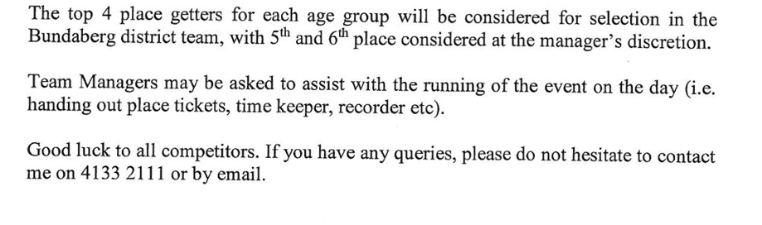

Thanks,

Kara Hayden-Brooks

Sports Co-ordinator Gin Gin SHS